1. Stat Canada tweeted “Average hourly wages rose 5.3% (+$1.68 to $33.12) on a year-over-year basis in March 2023, compared with 5.4% in February (not seasonally adjusted).” (https://twitter.com/StatCan_eng/status/1645487113448693763). Perform the following requirements to analyze recent wages and inflation progression in Canada
   1. Show the data that proves this claim and compare it to the inflation rate (overall) in the last 4 years, on month basis, by plotting a graph. You are free to take decisions about this graph, but it should give a clear hindsight about the wage vs. inflation movement.

I proved the claim in two ways.

* 1. To prove the claim, I downloaded the data of March 2022 and March 2023 and that of February as well and find the year over year change and the percent change.

getwd () library(tidyverse) library(dplyr)

df1 = read.csv("march_22.csv") df2 = read.csv("march_23.csv") df = bind_rows (df1, df2)

df = data. frame (df$REF_DATE, df$GEO, df$Characteristics,df$VALUE) df= df%>% filter (df. Characteristics == "15 years and over")

df = df%>% mutate (change= df$df.VALUE-lag(df$df.VALUE)) df

df=df%>%mutate(percent_change=((df$df.VALUE-lag(df$df.VALUE))/lag(df$df.VALUE))

*100)

df

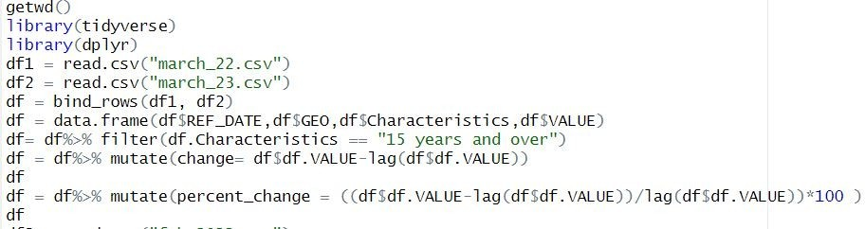

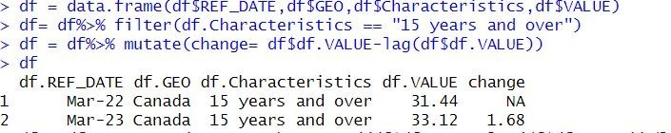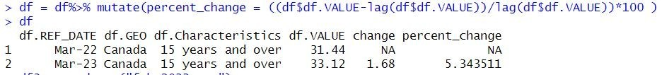

df3 = read.csv("feb_2022.csv") df4 = read.csv("feb_2023.csv") df5 = bind_rows(df3,df4)

df5 = data.frame(df5$REF_DATE,df5$GEO,df5$Characteristics,df5$VALUE) df5= df5%>% filter(df5.Characteristics == "15 years and over")

df5 = df5%>% mutate(change= df5$df5.VALUE-lag(df5$df5.VALUE)) df5

df5 = df5%>% mutate(percent_change =

((df5$df5.VALUE-lag(df5$df5.VALUE))/lag(df5$df5.VALUE))*100 ) df5

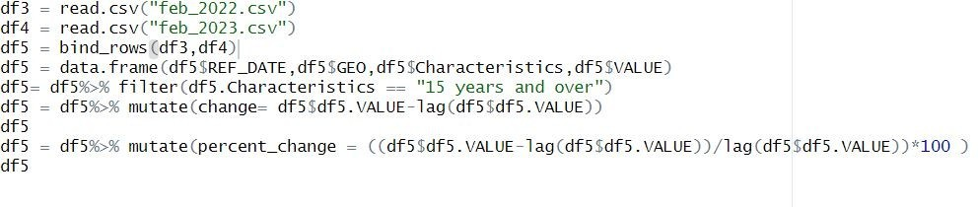

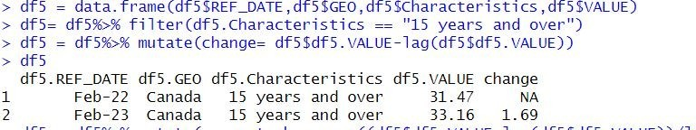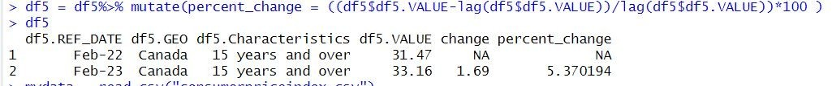

Thus, we can see that the average hourly wages increase by $1.68 from March 2022 to March 2023, an increase of 5.3%. But in February2023 there is an increase of $1.69 as compared to the same month of 2022, an increase of 5.37%, i.e., 5.4%. This proves the claim that “Average hourly wages rose 5.3% (+$1.68 to $33.12) on a year-over-year basis in March 2023, compared with 5.4% in February (not seasonally adjusted).” (https://twitter.com/StatCan_eng/status/1645487113448693763).

* 1. I also proved the claim by taking the average hourly wages data for the last 5 years and find the year over year change for the last 4 years.

getwd() library(tidyverse) library(dplyr)

mydata = read.csv("hourlywages_canada.csv")

typeof(mydata$REF_DATE)

mydata$REF_DATE <- as.Date(paste0("01-", mydata$REF_DATE), format = "%d-%b-%y") mydata =

data.frame(mydata$REF_DATE,mydata$GEO,mydata$North.American.Industry.Classification.System..NAIC S.,mydata$VALUE)

mydata = mydata%>% filter(mydata.North.American.Industry.Classification.System..NAICS.=="Total employees, all industries")

mydata

df = mydata%>% mutate(change= mydata$mydata.VALUE-lag(mydata$mydata.VALUE,12)) df

df= df%>% mutate(percent_change =

((mydata$mydata.VALUE-lag(mydata$mydata.VALUE,12))/lag(mydata$mydata.VALUE,12))*100 ) df

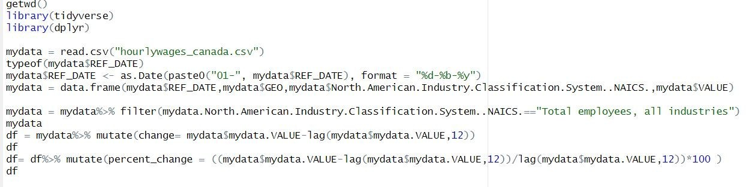

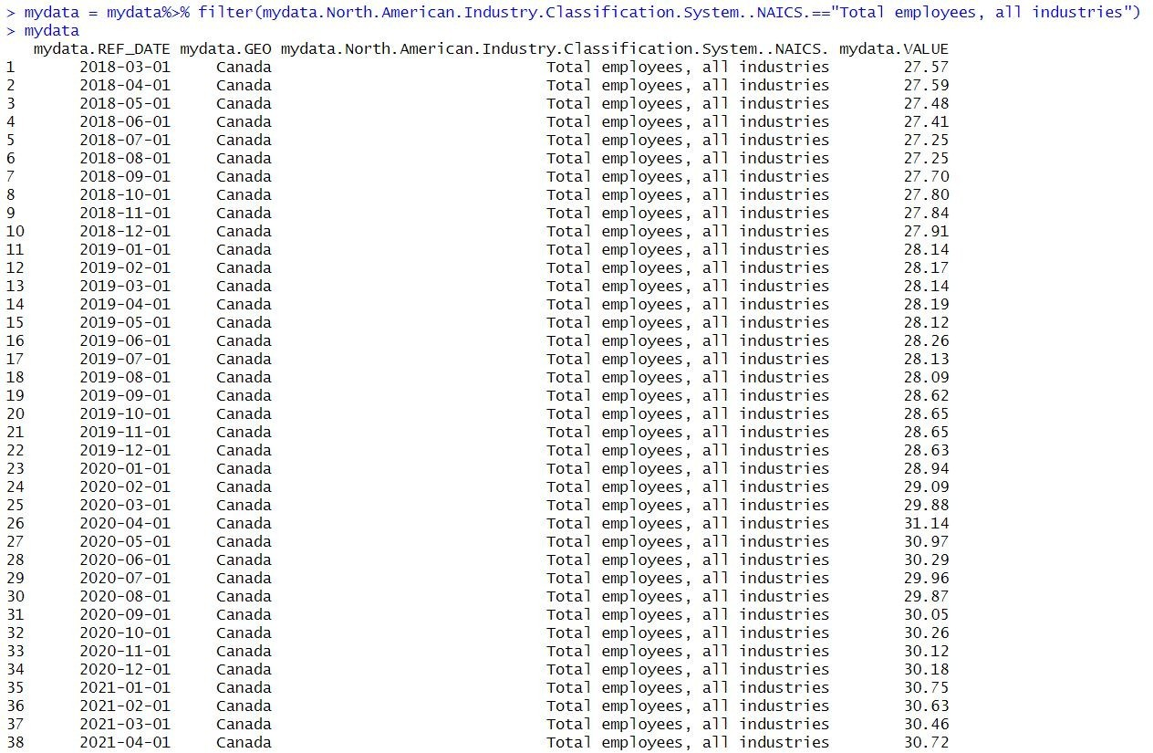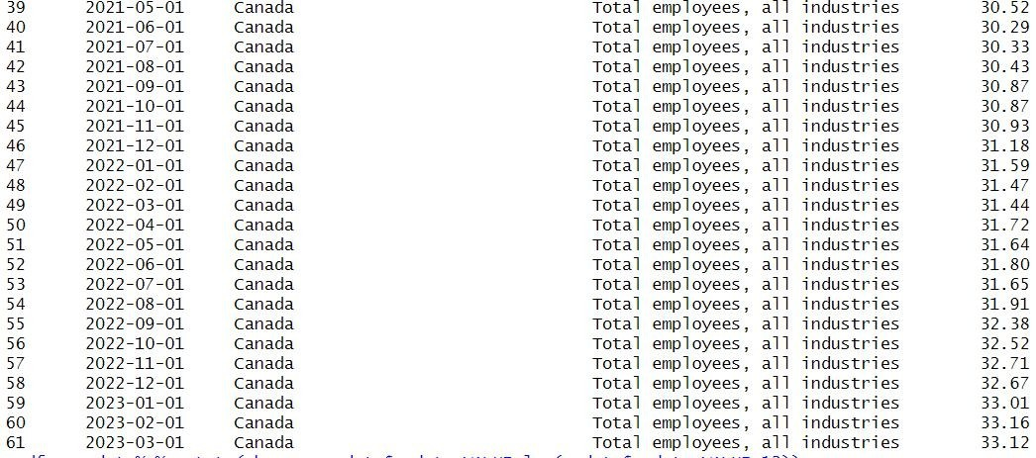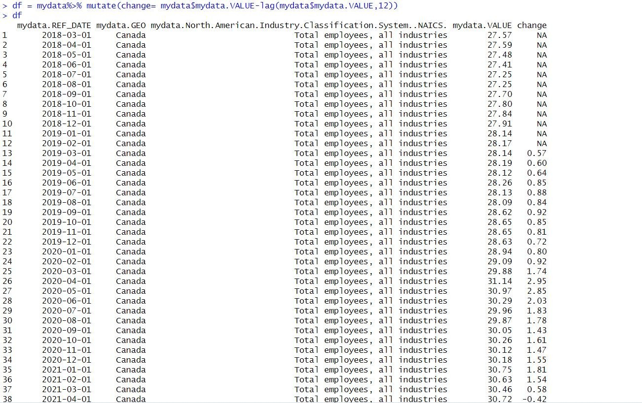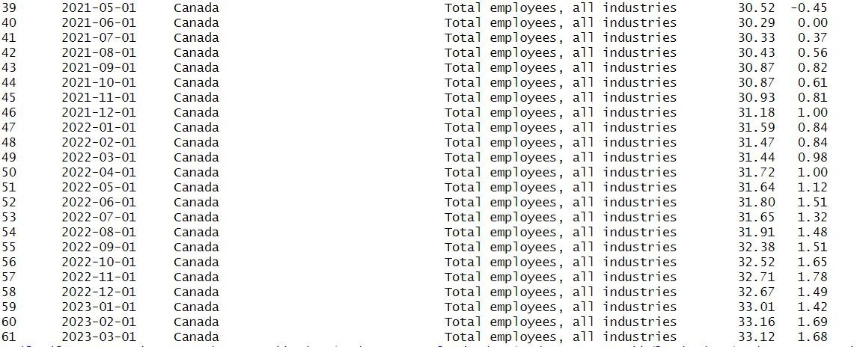

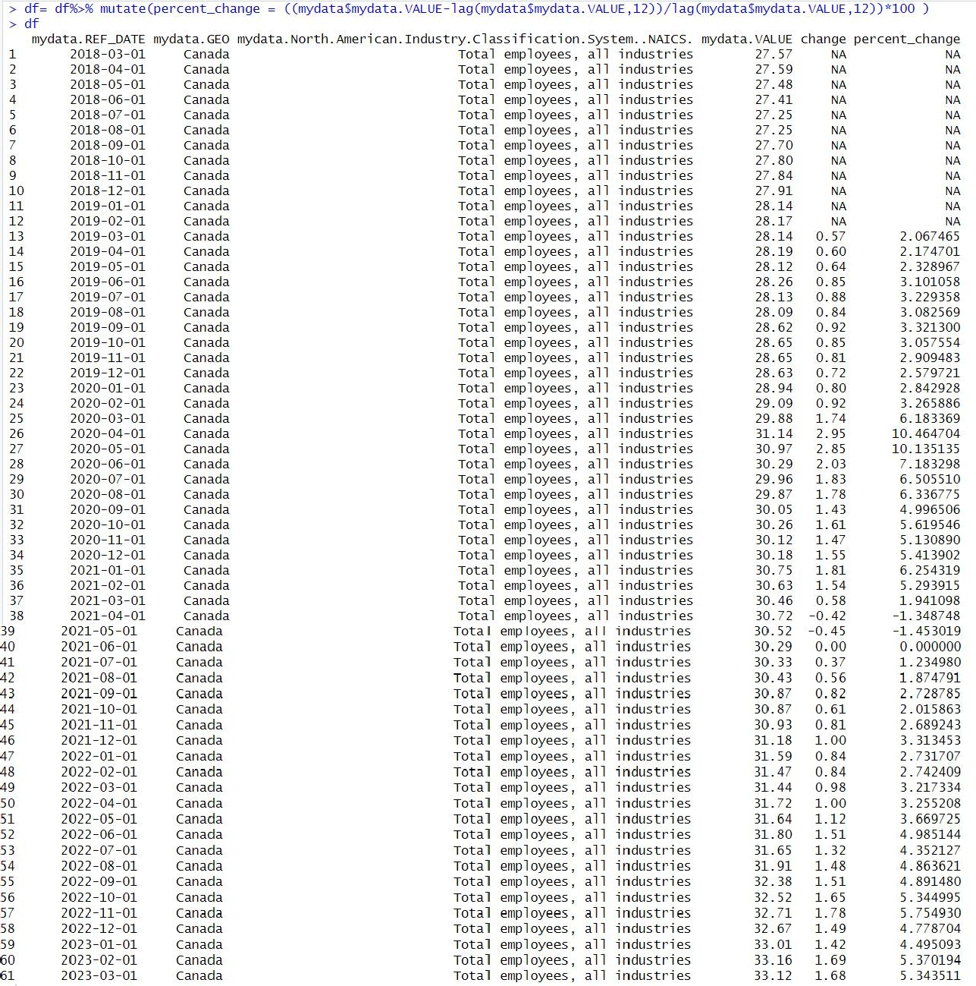This also proves the claim as we can see that the year over year change in February 2023 is 1.69, an increase of 5.4% and in March there is an increase of $1.68 to $

33.12 i.e., an increase of 5.3%.

The next task is to find the inflation rate over the last 4 years on months basis and compare with the above change in average hourly wages in Canada.

mydata2 = read.csv("CPI_Canada.csv")

typeof(mydata2$REF_DATE)

mydata2$REF_DATE <- as.Date(paste0("01-", mydata2$REF_DATE), format = "%d-%b-%y") data= data.frame(mydata2$REF_DATE,mydata2$Products.and.product.groups,mydata2$VALUE) df1 = data%>%filter(mydata2.REF_DATE >'2018-02-01')

df1

df1 = df1%>%filter(mydata2.Products.and.product.groups =='All-items') df1

df1 = df1 %>% mutate(percent_change= ((df1$mydata2.VALUE lag(df1$mydata2.VALUE,12))/lag(df1$mydata2.VALUE,12))*100) df1

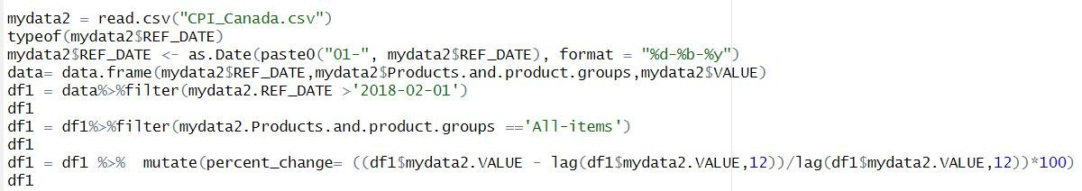

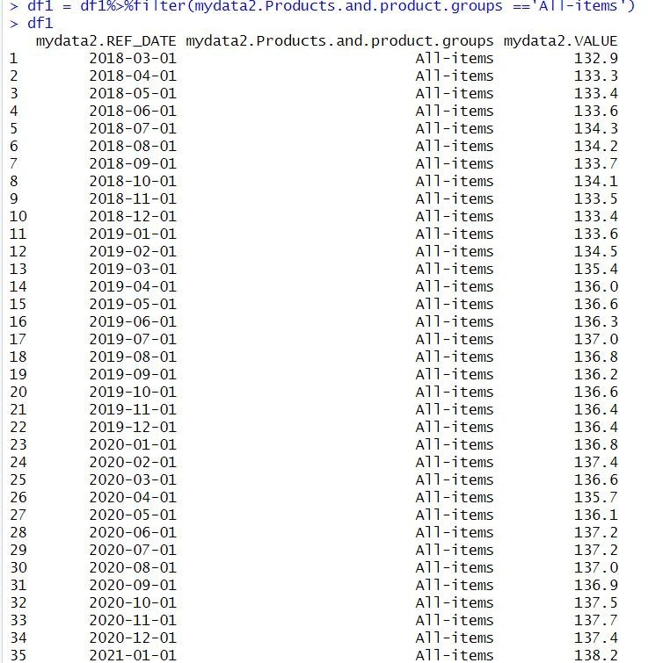

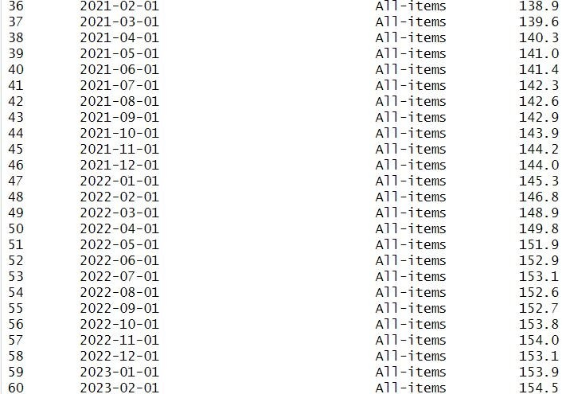

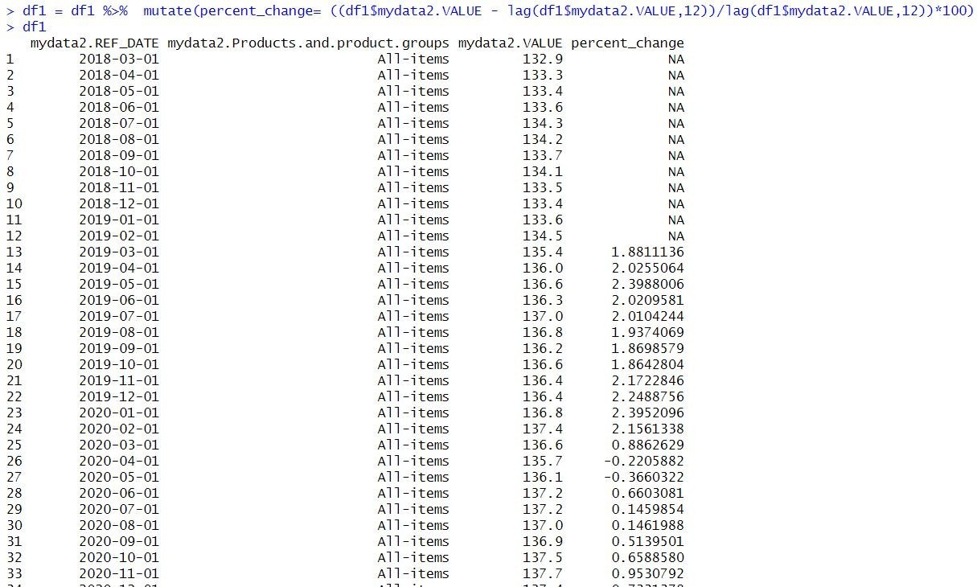

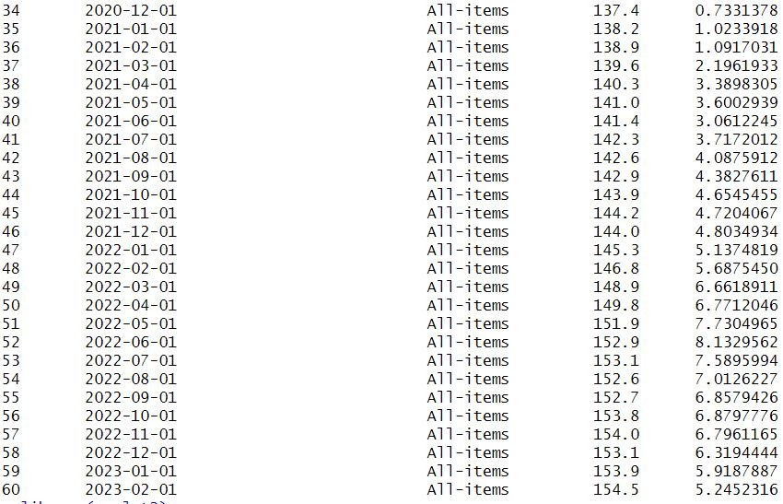

Plotting the percent_change of inflation vs average hourly wages for the last 4 years in Canada. library(ggplot2)

# Convert the data frames to tibbles

df2_tib <- tibble(REF_DATE = df$mydata.REF_DATE, percent_change = df$percent_change) df3_tib <- tibble(REF_DATE = df1$mydata2.REF_DATE, percent_change = df1$percent_change)

ggplot() +

geom_line(data = df2_tib, aes(x = REF_DATE, y = percent_change, color = "Hourly Wages"), size = 1) + geom_line(data = df3_tib, aes(x = REF_DATE, y = percent_change, color = "Inflation Rate"), size = 1) + scale_color_manual(name = "Legend", values = c("Inflation Rate" = "red", "Hourly Wages" = "blue")) + ylim(-6, 12) +

xlim(as.Date("2019-01-01"), as.Date("2023-04-01")) +

ggtitle("Inflation vs Hourly Wages-Canada") + xlab("Date") +

ylab("Percent_Change")+

scale_x_date(date_breaks = "1 month", date_labels = "%Y-%b-%d",limits = as.Date(c("2019-01-01", "2023-04- 01")))+

theme(axis.text.x = element_text(angle = 45, hjust = 1))

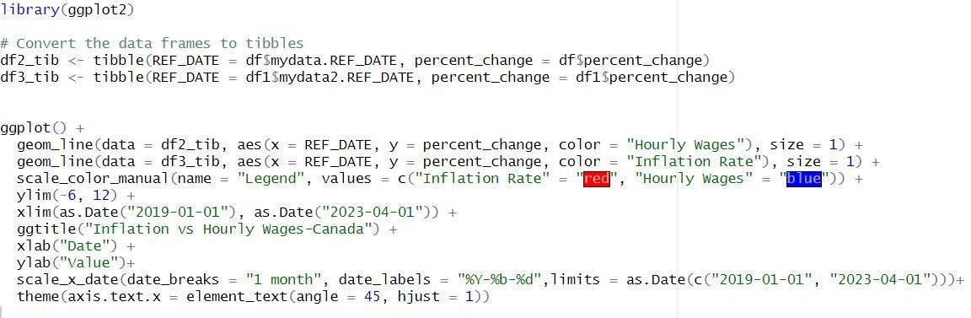

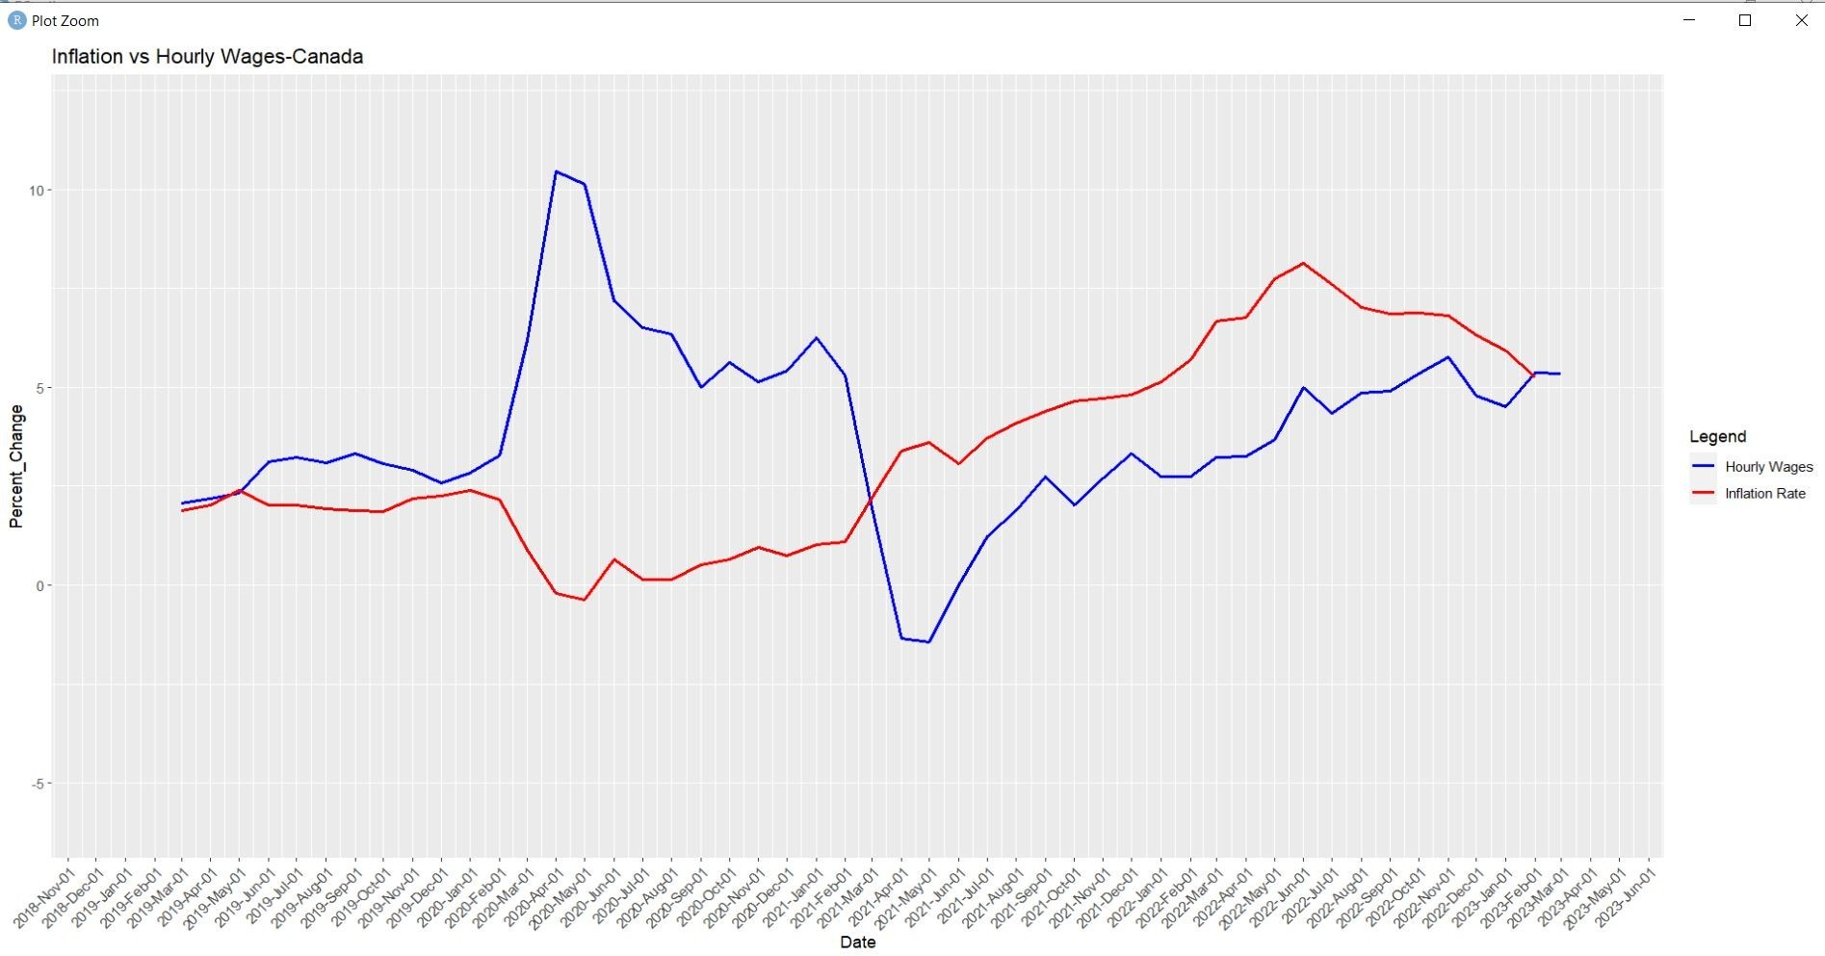

* 1. Based on data obtained from Stats Canada, make another graph about the same concepts above but for Ontario.

Now I compared the inflation rate and rate of change of average hourly wages for the last 4 years year over year on months basis for Ontario.

getwd() library(tidyverse) library(dplyr)

mydata = read.csv("CPI_Ontario.csv") typeof(mydata$REF_DATE)

mydata$REF_DATE <- as.Date(paste0("01-", mydata$REF_DATE), format = "%d-%b-%y")

df = data.frame(mydata$REF_DATE,mydata$GEO,mydata$Products.and.product.groups,mydata$VALUE)

df1 = df%>%filter(mydata.Products.and.product.groups =='All-items') df1 = df1%>%filter(mydata.REF_DATE >'2018-02-01')

df1

df1 = df1 %>% mutate(percent_change= ((df1$mydata.VALUE - lag(df1$mydata.VALUE,12))/lag(df1$mydata.VALUE,12))*100)

df1

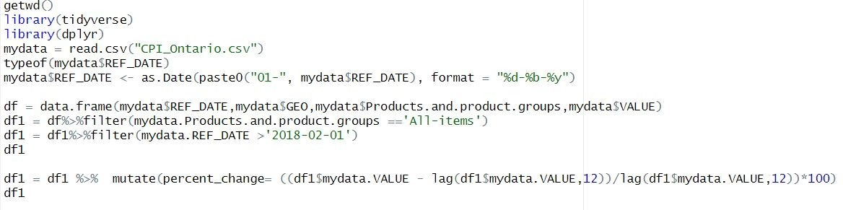

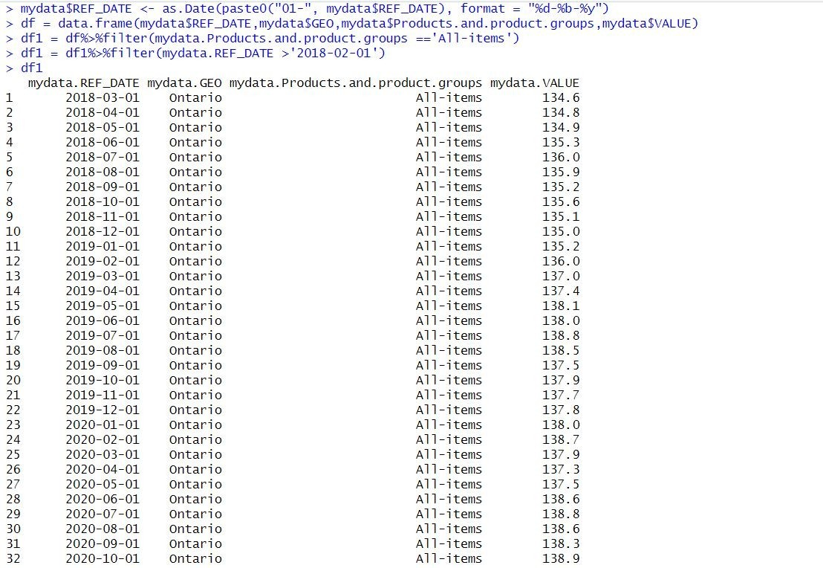

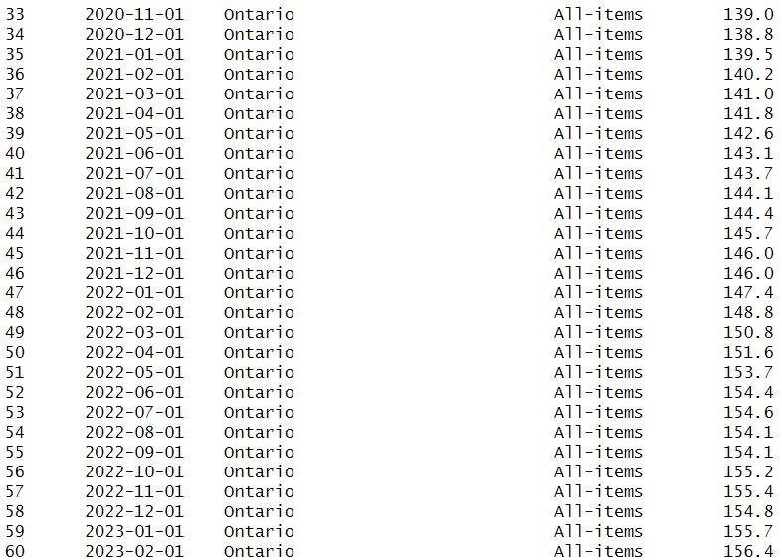

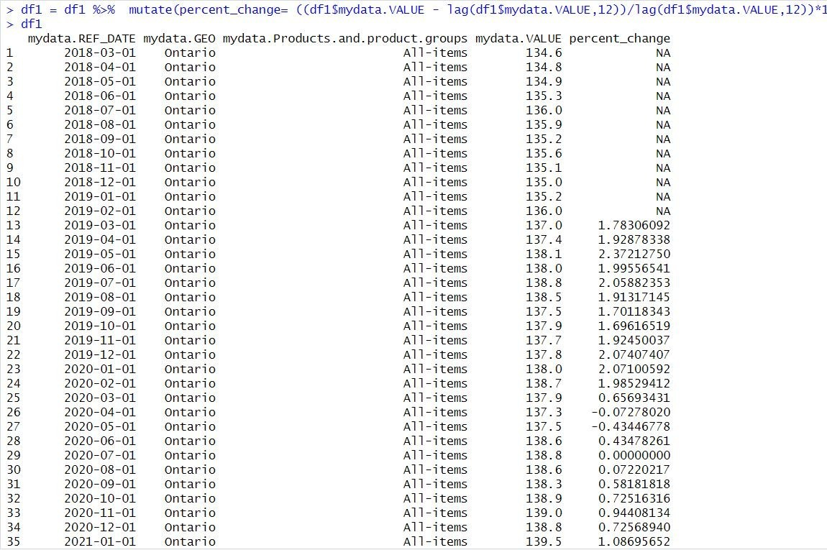

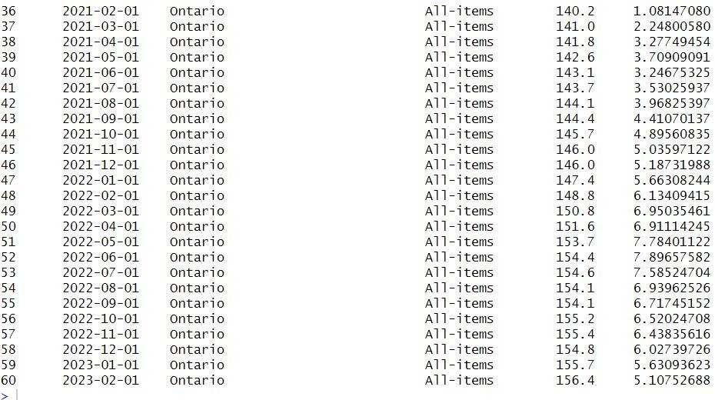

mydata2 = read.csv("hourlywages_ontario.csv")

typeof(mydata2$REF_DATE)

mydata2$REF_DATE <- as.Date(paste0("01-", mydata2$REF_DATE), format = "%d-%b-%y") mydata2 =

data.frame(mydata2$REF_DATE,mydata2$GEO,mydata2$North.American.Industry.Classification.Syste m..NAICS.,mydata2$VALUE)

mydata2 = mydata2%>% filter(mydata2.North.American.Industry.Classification.System..NAICS.=="Total employees, all industries")

df2= mydata2%>% mutate(percent_change = ((mydata2$mydata2.VALUE- lag(mydata2$mydata2.VALUE,12))/lag(mydata2$mydata2.VALUE,12))*100 )

df2

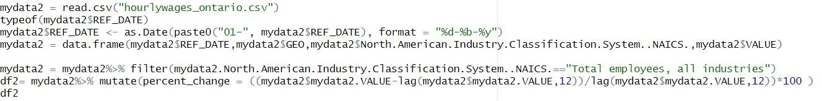

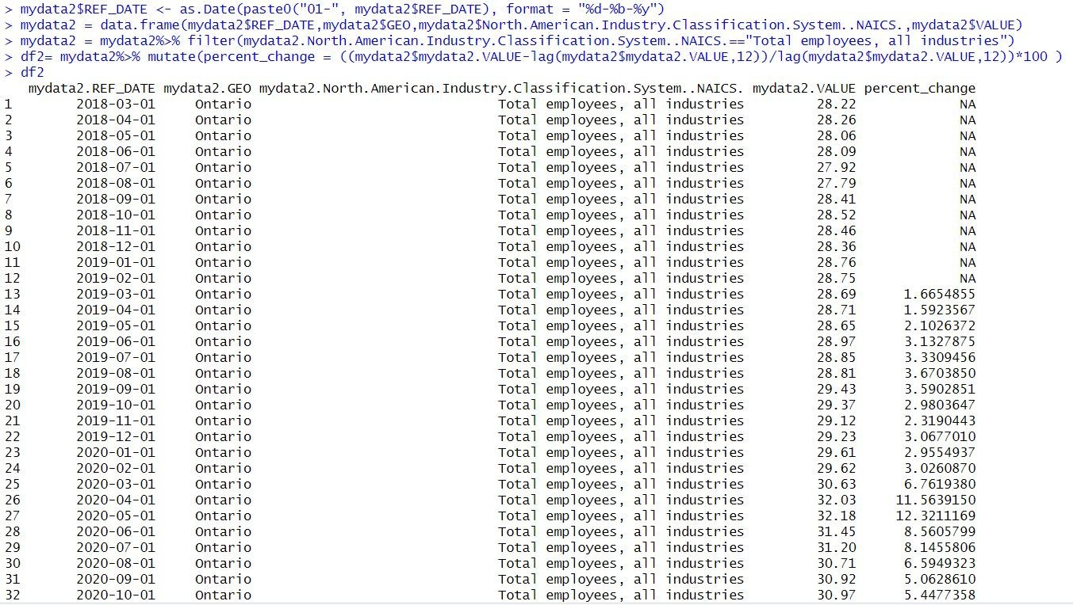

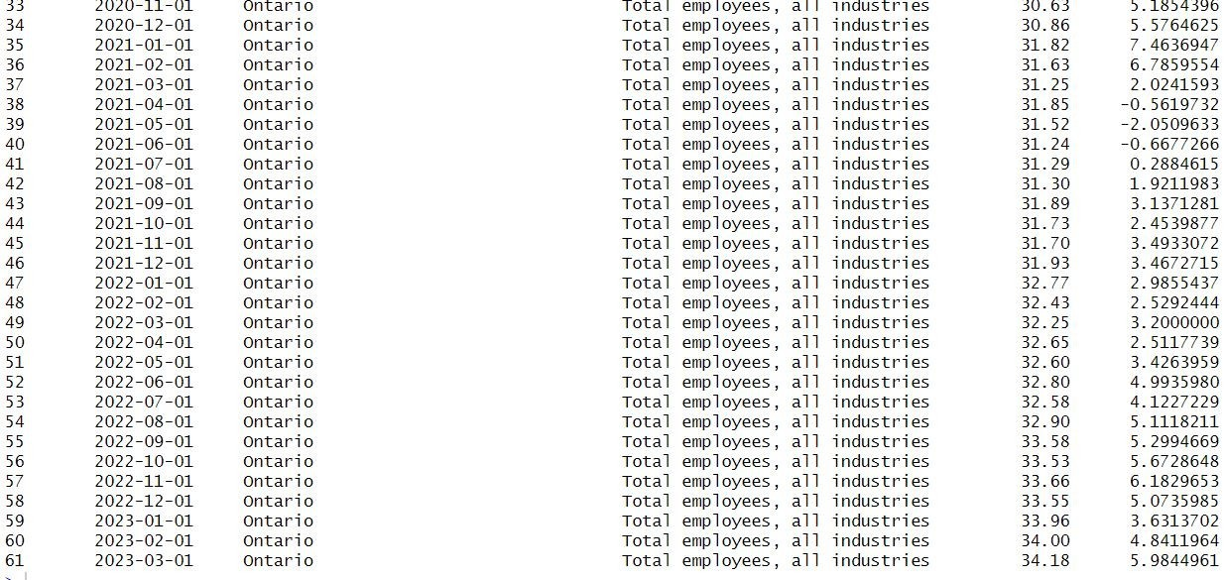

Next I plot the inflation rate vs rate of change of average hourly wages for the last 4 years for Ontario.

# Load the ggplot2 library

library(ggplot2)

# Convert the data frames to tibbles

df1_tib <- tibble(REF_DATE = as.Date(df1$mydata.REF_DATE), percent_change = df1$percent_change)

df2_tib <- tibble(REF_DATE = as.Date(df2$mydata2.REF_DATE), percent_change = df2$percent_change)

ggplot() +

geom_line(data = df1_tib, aes(x = REF_DATE, y = percent_change, color = "Inflation Rate"), size = 1)

+

geom_line(data = df2_tib, aes(x = REF_DATE, y = percent_change, color = "Hourly Wages"), size = 1)

+

scale_color_manual(name = "Legend", values = c("Inflation Rate" = "red", "Hourly Wages" = "blue"))

+

ylim(-6, 14) +

xlim(as.Date("2019-01-01"), as.Date("2023-12-31")) +

ggtitle("Inflation vs Avg.Hourly Wages-Ontario") + xlab("Date") +

ylab("Percent_Change")+

scale_x_date(date_breaks = "1 month", date_labels = "%Y-%b-%d",limits = as.Date(c("2019-01-01", "2023-04-01")))+

theme(axis.text.x = element_text(angle = 45, hjust = 1))

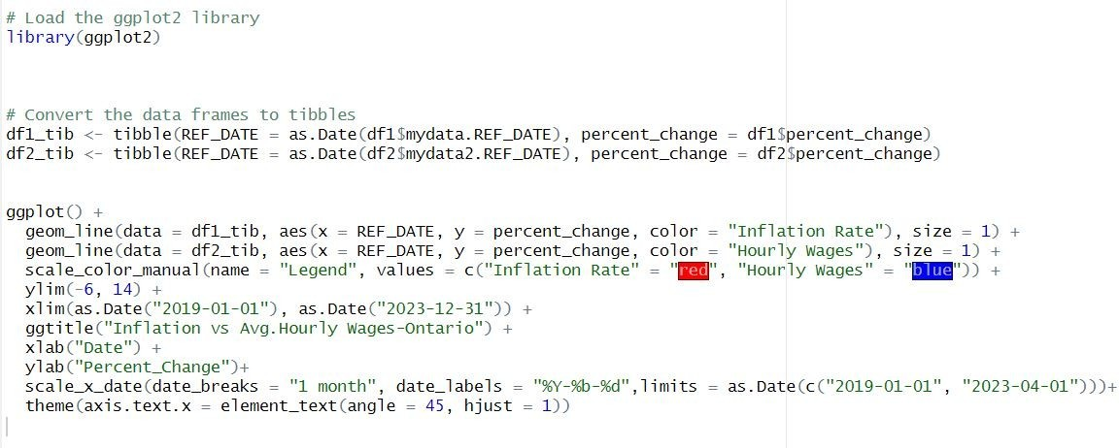

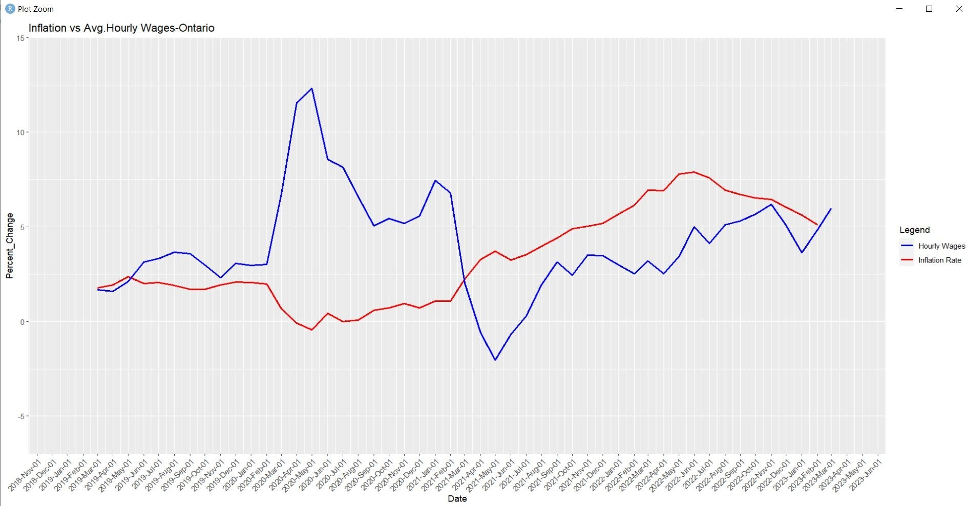

* 1. Based on the two graphs above, and in 400-500 words, analyse the progression in Ontario resident’s financial ability over the last 4 years vs Canada’s.

From the first graph we can see that before 2021 the rate of change in average hourly wages is much more than the percent change in inflation rate. Hourly wages started at around 2.5 percent change in 2019, increased to a peak of around 10% in mid-2021 and then declined gradually. But after 2021 we can see a significant decrease in the rate of change of average hourly wages with a significant increase in the inflation rate.

Consumer prices rose faster than average hourly wages on a year over year basis from October 2021,meaning Canadians experienced a decline in purchasing power. Even

though it is claimed that there is a 5.4% increase in average hourly wages in February 2023 year on year basis, the inflation rate of February 2023 is much higher than that of the same month last year. Thus, Canadians are facing an uphill battle trying to keep pace with the inflation. Even there is a steady increase in average hourly wages after May 2021, but never quite matched the pace of price pressures. Canadians who are unable to locate higher paying employment or negotiate a raise in pay are compelled to restrict their budgets when earnings are unable to keep up with inflation. People with lower salaries, even lower than the average salary have really been stretched over the last 2 years especially because of the significant increase in the cost of living. By 2022 October there seen a decrease in the inflation rate and can seen that it reaches nearly the percentage change for the average hourly wages. If the inflation rate follows a similar trend in the future regarding the average hourly rate there will be a relief for the Canadians from the stress they are facing nowadays.

In the case of Ontario, it also followed a similar pattern as that of nation. While Ontario’s inflation rate has been marginally lower than the national average, its average hourly rate has been marginally higher than the national average. At the beginning of 2019 the inflation rate is higher than the percent change in hourly rate but soon it becomes lower than the hourly rate. By mid 2020, there is a huge increase in average hourly wages as compared to the same period of 2019. Thus, during this period Ontario residents has high purchasing power as the inflation rate is lower. After this period, we can see a steady increase in the inflation rate as compared to the previous year. This may be due to the high purchasing power enjoyed by the residents during the previous months. In May 2021 we can see a deep decline in the percentage change in the average hourly wages as compared to the previous May. While the inflation percent change is much higher. But we can see that the difference is lower than the national difference. But as we reached 2023, the percent change became similar for both. Thus overall, we can say that the financial stability of Ontario residents is higher than the financial stability of Canada. And the financial stability is now in the path of an improvement as compared to the previous two years.